SDEV1201 — Day 10 Run Sheet
Primary Keys · Foreign Keys · Not Null / Null · Drop & Create Order
Segment 1 — Welcome & What's New Today

Last class you built the Monthly Desk tables with just column names and datatypes — nothing enforced anything. Today you're rebuilding the same nine tables with three new pieces added to every column:
Primary Key (PK) — uniquely identifies every row in a table. Every table gets exactly one.
Foreign Key (FK) — a column that links to another table's Primary Key. This is what actually connects the tables together.
Not Null / Null, named — same concept as last class, but now every constraint gets its own name instead of just the keyword.

In SDEV1201, constraint names are mandatory — every Primary Key, Foreign Key, and Not Null/Null gets an explicit Constraint name. The naming pattern we use all term:
PK_TableName_ColumnName — Primary Key
FK_ChildTable_ChildColumn_ParentTable_ParentColumn — Foreign Key
NN_TableName_ColumnName — Not Null
NL_TableName_ColumnName — Null
One column can carry more than one constraint — OfficeTypeCode, for example, is both the Primary Key and Not Null at the same time.
SQL Constraints
SQL constraints are rules for data in a table.
Constraints are used to prevent insertion of invalid data in a table, and ensures the accuracy and reliability of the data in the table. If there is any violation between the constraint and the data action, the action is aborted.
Constraints can be specified in two ways:
When a table is created (through the CREATE TABLE statement)
After a table is created (through the ALTER TABLE statement)
SQL Constraint Types
The following constraints are commonly used in SQL:
NOT NULL - Ensures that a column cannot have a NULL value
UNIQUE - Ensures that all values in a column are unique
PRIMARY KEY - Uniquely identifies each row in a table (a combination of a NOT NULL and UNIQUE)
FOREIGN KEY - Establishes a link between data in two tables, and prevents action that will destroy the link between them
CHECK - Ensures that the values in a column satisfies a specific condition
DEFAULT - Sets a default value for a column if no value is specified
CREATE INDEX - Creates indexes on columns to retrieve data from the database faster
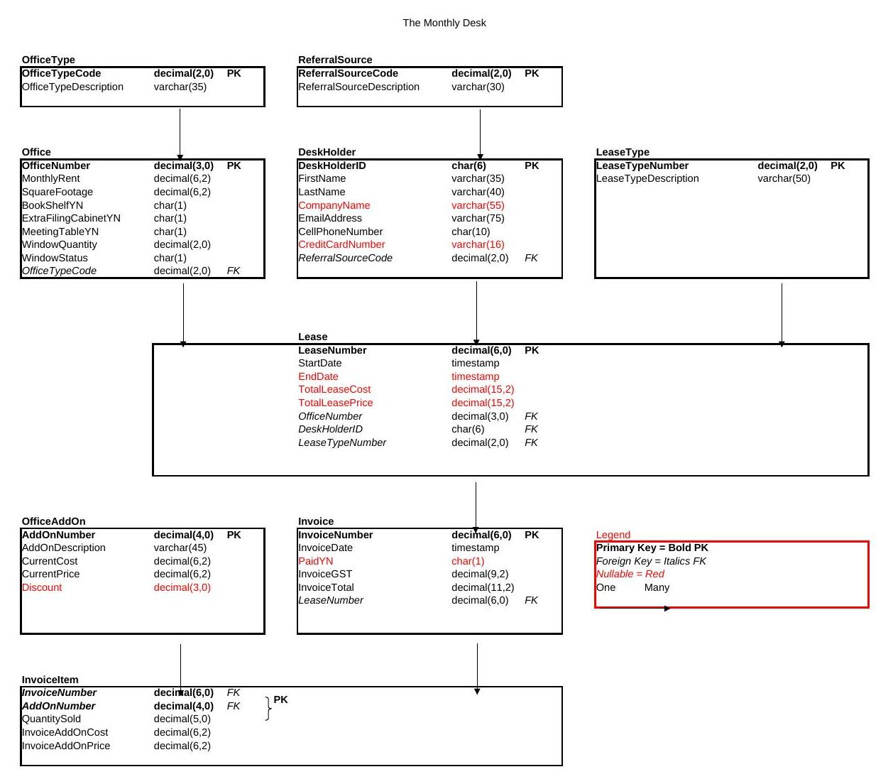

Segment 2 — Drop Order Now Matters

Last class, table order didn't matter — nothing was linked. Today, once a Foreign Key exists, PostgreSQL won't let you drop a table that something else still points to. Child tables — the ones with the Foreign Keys — have to go first.
Here's the drop order for the whole Monthly Desk, reverse of how we'll create them:
Drop Table If Exists InvoiceItem;
Drop Table If Exists Invoice;
Drop Table If Exists OfficeAddOn;
Drop Table If Exists Lease;
Drop Table If Exists LeaseType;
Drop Table If Exists DeskHolder;
Drop Table If Exists Office;
Drop Table If Exists ReferralSource;
Drop Table If Exists OfficeType;
Run all of this first, before anything else — a clean slate.
InvoiceItem references Invoice and OfficeAddOn — drop it first.
Invoice references Lease — drop it before Lease.
Lease references Office, DeskHolder, and LeaseType — drop it before those three.
The rest don't reference anything — they're safe to drop last.

Segment 3 — Create the Parent Tables

Parent tables don't reference anything else, so they're created first. Run these one at a time — click inside a statement and press F5.

OfficeType

Create Table OfficeType -- OT
(
OfficeTypeCode decimal(2,0) Constraint PK_Office_OfficeTypeCode
Primary Key
Constraint NN_Office_OfficeTypeCode
Not Null,
OfficeTypeDescription varchar(35) Constraint NN_Office_OfficeTypeDescription
Not Null
);
Select * From OfficeType;
Constraint PK_... names the Primary Key. Constraint NN_... names the Not Null. OfficeTypeCode carries both — a column can have more than one constraint stacked on it.

ReferralSource

Create Table ReferralSource -- RS
(
ReferralSourceCode decimal(2,0) Constraint PK_ReferralSource_ReferralSourceCode
Primary Key
Constraint NN_ReferralSource_ReferralSourceCode
Not Null,
ReferralSourceDescription varchar(30) Constraint NN_ReferralSource_ReferralSourceDescription
Not Null
);

Select * From ReferralSource;
Same pattern as OfficeType — Primary Key and Not Null, both named, on the code column.

Office

Create Table Office -- Off
(
OfficeNumber decimal(3,0) Constraint PK_Office_OfficeNumber
Primary Key
Constraint NN_Office_OfficeNumber
Not Null,
MonthlyRent decimal(6,2) Constraint NN_Office_MonthlyRent
Not Null,
SquareFootage decimal(6,2) Constraint NN_Office_SquareFootage
Not Null,
BookShelfYN char(1) Constraint NN_Office_BookShelfYN
Not Null,
ExtraFilingCabinetYN char(1) Constraint NN_Office_ExtraFilingCabinetYN
Not Null,
MeetingTableYN char(1) Constraint NN_Office_MeetingTableYN
Not Null,
WindowQuantity decimal(2,0) Constraint NN_Office_WindowQuantity
Not Null,
WindowStatus char(1) Constraint NN_Office_WindowStatus
Not Null,
OfficeTypeCode decimal(2,0) Constraint NN_Office_OfficeTypeCode
Not Null
Constraint FK_Office_OfficeTypeCode_OfficeType_OfficeTypeCode
References OfficeType (OfficeTypeCode)
);

Select * From Office;
OfficeTypeCode at the bottom is this table's first Foreign Key — it references the OfficeTypeCode column in OfficeType. Read any FK out loud like this: "The OfficeTypeCode column in Office references the OfficeTypeCode column in OfficeType." That sentence is what makes it a Foreign Key. The FK constraint name follows the full pattern: FK_ChildTable_ChildColumn_ParentTable_ParentColumn.

DeskHolder

Create Table DeskHolder -- DH
(
DeskHolderID char(6) Constraint PK_DeskHolder_DeskHolderID
Primary Key
Constraint NN_DeskHolder_DeskHolderID
Not Null,
FirstName varchar(35) Constraint NN_DeskHolder_FirstName
Not Null,
LastName varchar(40) Constraint NN_DeskHolder_LastName
Not Null,
CompanyName varchar(55) Constraint NN_DeskHolder_CompanyName
Null,
EmailAddress varchar(75) Constraint NN_DeskHolder_EmailAddress
Not Null,
CellPhoneNumber char(10) Constraint NN_DeskHolder_CellPhoneNumber
Not Null,
CreditCardNumber varchar(16) Constraint NL_DeskHolder_CreditCardNumber
Null,
ReferralSourceCode decimal(2,0) Constraint NN_DeskHolder_ReferralSourceCode
Not Null
Constraint FK_DeskHolder_ReferralSourceCode_RS_ReferralSourceCode
References ReferralSource (ReferralSourceCode)
);

Select * From DeskHolder;
CompanyName and CreditCardNumber are Null, not Not Null — a desk holder might not have a company or a card on file yet. Both get the NL_ prefix, matching the Null keyword they're actually enforcing.
That last Foreign Key uses RS instead of spelling out ReferralSource. That's not a shortcut for style — PostgreSQL caps constraint names at 63 characters, and the fully spelled-out version runs over that limit. When a name would run long, abbreviate the parent table consistently, but keep every other part of the pattern intact.

LeaseType

Create Table LeaseType -- LT
(
LeaseTypeNumber decimal(2,0) Constraint PK_LeaseType_LeaseTypeNumber
Primary Key
Constraint NN_LeaseType_LeaseTypeNumber
Not Null,
LeaseTypeDescription varchar(50) Constraint NN_LeaseType_LeaseTypeDescription
Not Null
);

Select * From LeaseType;
Straightforward — Primary Key on the number column, Not Null on both.

Lease

Create Table Lease -- LSE
(
LeaseNumber decimal(6,0) Constraint PK_Lease_LeaseNumber
Primary Key
Constraint NN_Lease_LeaseNumber
Not Null,
StartDate timestamp Constraint NN_Lease_StartDate
Not Null,
EndDate timestamp Constraint NL_Lease_EndDate
Null,
TotalLeaseCost decimal(15,2) Constraint NL_Lease_TotalLeaseCost
Null,
TotalLeasePrice decimal(15,2) Constraint NL_Lease_TotalLeasePrice
Null,
OfficeNumber decimal(3,0) Constraint NN_Lease_OfficeNumber
Not Null
Constraint FK_Lease_OfficeNumber
References Office (OfficeNumber),
DeskHolderID char(6) Constraint NN_Lease_DeskHolderID
Not Null
Constraint FK_Lease_DeskHolderID_DeskHolder_DeskHolderID
References DeskHolder (DeskHolderID),
LeaseTypeNumber decimal(2,0) Constraint NN_Lease_LeaseTypeNumber
Not Null
Constraint FK_Lease_LeaseTypeNumber_LeaseType_LeaseTypeNumber
References LeaseType (LeaseTypeNumber)
);

Select * From Lease;

OfficeAddOn

Create Table OfficeAddOn -- OAO
(
AddOnNumber decimal(4,0) Constraint PK_OfficeAddOn_AONum
Primary Key
Constraint NN_OfficeAddOn_AONum
Not Null,
AddOnDescription varchar(45) Constraint NN_OfficeAddOn_AddOnDescription
Not Null,
CurrentCost decimal(6,2) Constraint NN_OfficeAddOn_CurrentCost
Not Null,
CurrentPrice decimal(6,2) Constraint NN_OfficeAddOn_CurrentPrice
Not Null,
Discount decimal(3,0) Constraint NN_OfficeAddOn_Discount
Null
);

Select * From OfficeAddOn;
Discount is Null — not every add-on is discounted.Three Foreign Keys in one table — Lease is what connects Office, DeskHolder, and LeaseType. Each FK's datatype has to match its parent's Primary Key exactly: OfficeNumber is decimal(3,0) in both places, DeskHolderID is char(6) in both, LeaseTypeNumber is decimal(2,0) in both.

Invoice

Create Table Invoice -- Inv
(
InvoiceNumber decimal(6,0) Constraint PK_Invoice_InvoiceNumber
Primary Key
Constraint NN_Invoice_InvoiceNumber
Not Null,
InvoiceDate timestamp Constraint NN_Invoice_InvoiceDate
Not Null,
PaidYN char(1) Constraint NL_Invoice_PaidYN
Null,
InvoiceGST decimal(9,2) Constraint NN_Invoice_InvoiceGST
Not Null,
InvoiceTotal decimal(11,2) Constraint NN_Invoice_InvoiceTotal
Not Null,
LeaseNumber decimal(6,0) Constraint NN_Invoice_LeaseNumber
Not Null
Constraint FK_Invoice_LeaseNumber_Lease_LeaseNumber
References Lease (LeaseNumber)
);

Select * From Invoice;
LeaseNumber is the Foreign Key back to Lease — one lease can have many invoices over time.

InvoiceItem

Create Table InvoiceItem -- II
(
InvoiceNumber decimal(6,0) Constraint NN_InvoiceItem_InvoiceNumber
Not Null
Constraint FK_InvoiceItem_InvoiceNumber_Invoice_InvoiceNumber
References Invoice (InvoiceNumber),
AddOnNumber decimal(4,0) Constraint NN_InvoiceItem_AddOnNumber
Not Null
Constraint FK_InvoiceItem_AddOnNumber_OfficeAddOn_AddOnNumber
References OfficeAddOn (AddOnNumber),
QuantitySold decimal(5,0) Constraint NN_InvoiceItem_QuantitySold
Not Null,
InvoiceAddOnCost decimal(6,2) Constraint NN_InvoiceItem_InvoiceAddOnCost
Not Null,
InvoiceAddOnPrice decimal(6,2) Constraint NN_InvoiceItem_InvoiceAddOnPrice
Not Null,
Constraint PK_InvoiceItem_InvoiceNumber_AddOnNumber
Primary Key (InvoiceNumber, AddOnNumber)
);

Select * From InvoiceItem;
This is the composite Primary Key we flagged last class. Neither InvoiceNumber nor AddOnNumber is unique on its own — one invoice can have many add-ons, one add-on can appear on many invoices. Together, that pair is unique, which is why the Primary Key is declared at the table level, after every column, instead of attached to one column like everywhere else today. Both columns are also Foreign Keys — a column can be an FK and part of a composite PK at the same time.

Segment 5 — Indexes
An index is a separate structure PostgreSQL builds next to a table, so it doesn't have to scan every row to find what you're looking for — think of it like the index at the back of a textbook instead of reading every page.

The benefit — two of them:
Faster searches. Looking something up by an indexed column is much quicker on a large table — the difference is barely noticeable on our small practice tables, but on a table with a million rows it's the difference between instant and slow.
Faster joins. When tables get connected together later this term, PostgreSQL uses indexes to match rows between tables quickly instead of comparing every row in one table against every row in the other.

The cost — indexes aren't free, which is why we don't index every column:
Extra storage. Each index is its own structure on disk, roughly sized to the column it's indexing — more indexes, more disk space used.
Slower writes. Every time a row is inserted, updated, or deleted, PostgreSQL has to update every index on that table too, not just the table itself.

That trade-off is why the rule is targeted, not "index everything": index a column you'll actually search or sort by often.
Every table you just built already has an index you didn't ask for. PostgreSQL automatically builds one on every Primary Key, which is why you never write Create Index for a Primary Key column yourself — you just watched it happen nine times over. Foreign Keys don't get that for free: once a Foreign Key exists, the rule becomes "index every Foreign Key column" — that part's on you.

Try it now, on a table from last class:
Create Index IX_MickeyMouseStudent_LastName
On MickeyMouseStudent (LastName);

Select * From MickeyMouseStudent;

Drop Index IX_MickeyMouseStudent_LastName;

Indexes on Monthly Desk

Same pattern, on every Foreign Key column you built today. This is the rule from the callout above, applied for real — every one of these columns is a Foreign Key, and none of them got an index automatically:
Create Index IX_Office_OfficeTypeCode
On Office (OfficeTypeCode);

Create Index IX_DeskHolder_ReferralSourceCode
On DeskHolder (ReferralSourceCode);

Create Index IX_Lease_OfficeNumber
On Lease (OfficeNumber);

Create Index IX_Lease_DeskHolderID
On Lease (DeskHolderID);

Create Index IX_Lease_LeaseTypeNumber
On Lease (LeaseTypeNumber);

Create Index IX_InvoiceItem_InvoiceNumber
On InvoiceItem (InvoiceNumber);

Create Index IX_InvoiceItem_AddOnNumber
On InvoiceItem (AddOnNumber);

Create Index IX_Invoice_LeaseNumber
On Invoice (LeaseNumber);
LeaseNumber is the Primary Key over in Lease, so it's already indexed there — but this is Invoice.LeaseNumber, a Foreign Key in a different table. That automatic index doesn't carry over; this one still needs to be built by hand.
Segment 6 — Check Your Work

Every Create Table should have returned "Query returned successfully." To see the constraints themselves, not just the columns:
In the left-hand tree, expand your database, then Schemas, then public, then Tables. Right-click any table and choose Properties. The Columns tab shows every column with its datatype and Null/Not Null setting. The Constraints tab shows the Primary Key and any Foreign Keys by name — this is where you can check that a constraint name actually matches what we typed.

Segment 7 — See the Error on Purpose

Try dropping a parent table before its children, on purpose:
Drop Table OfficeType;
This fails. Something like: cannot drop table officetype because other objects depend on it. That's PostgreSQL protecting the Foreign Key — Office still has a column pointing at OfficeType, so OfficeType can't disappear out from under it.
The fix is the same order from Segment 2 — children first, parent last:
Drop Table If Exists InvoiceItem;
Drop Table If Exists Invoice;
Drop Table If Exists OfficeAddOn;
Drop Table If Exists Lease;
Drop Table If Exists LeaseType;
Drop Table If Exists DeskHolder;
Drop Table If Exists Office;
Drop Table If Exists ReferralSource;
Drop Table If Exists OfficeType;
Child first, then parent — always, from here on.

